1.A quarter of million 250000

2.Half a million 500000

3.A million 1000000

4.A quarter of an hour 15min

5.One seventy six 176

6.Seven nine o one thousand 7901000

7.Sixteen handred 1600

8.Point six 0.6

1.June the first

2.January the thirteenth, nineteen seventy three

3.The seventh of July

4.April the twenty third

5.March the twenty seventh, nineteen seventy two

6.The twelfth of June

7.March the twenty third

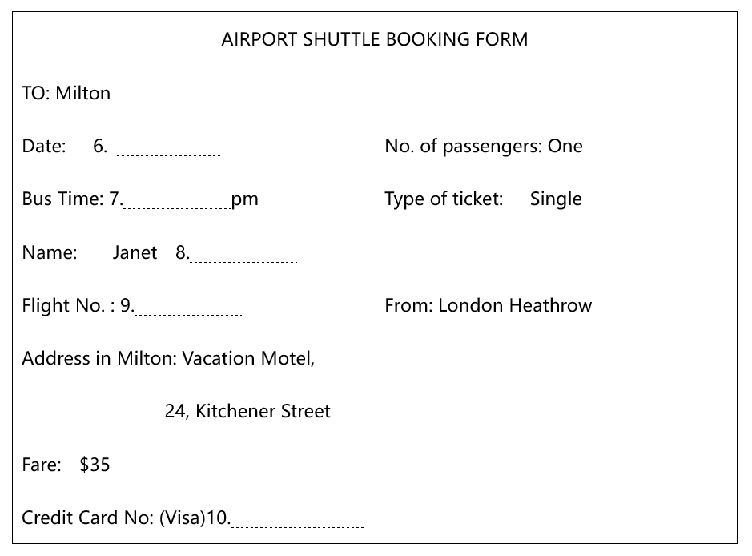



17th October

12:30

Thomson

AC936

3303845020456837